**Fitting Growth models loneliness development in children**

In this paper we describe various model to fit longitudinal data that describe the development of loneliness in children from 11 to 17 years old. The data consist of measurement of loneliness obtained from 129 children in four waves.

Plot the data

Simple growth model: Fit single line or curve

Model the variations of the children around the fitted curve, multilevel regression.

Variations of the children around the fitted curve are due to latent classes, latent class analysis.

Growth Mixture Models (GMM): there are latent classes and there is individual variation around the classes.

Bayesian estimation of GMM models

**Results**

(1) The average loneliness score drops slightly from 13 years (M=1.64, SE =0.60) old to 16 years old (M=1.49, SE = 0.46), which corresponds to a weak effect (Cohen’s d = .32 [0.05; 0.60]; t(183) = 1.97, *p* = .051). There is no significant difference in decrease in loneliness between men and women. The correlation between the two measures is .34 (p < .001). Looking further at the distribution of both loneliness variables 4 children can be viewed as outliers at the age of 13 years because they score three or higher, but at 16 years no outliers are present. See Figure 1 for the distributions of both loneliness variables.

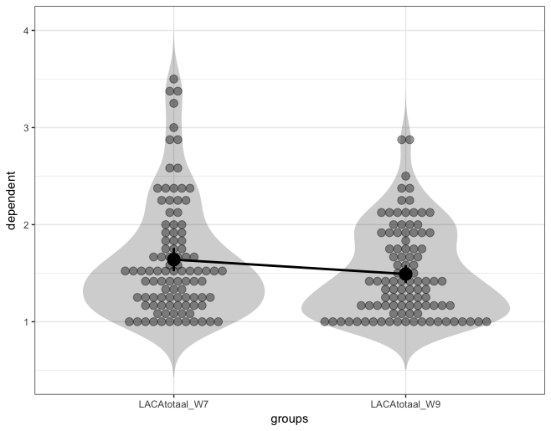

Figure 1. Distributions of loneliness variables at age 13 and 16 years respectively.

(2) Results from the analysis of the model to predict depression at 17 years by loneliness at respectively 13 years and 16 years, with both effects moderated by gender, show that both interaction effects are statistically significant, but opposite in sign. Furthermore, there is a statistically significant positive main effect of loneliness at 13 years. The covariate depression measured at 12 years is not associated with depression at 17.

To understand the combined effects we plotted the simple slope effects for boys and girls separately. In figure 2 the effect of loneliness at 13 years is shown and in figure 3 the effect of loneliness at 16 years.

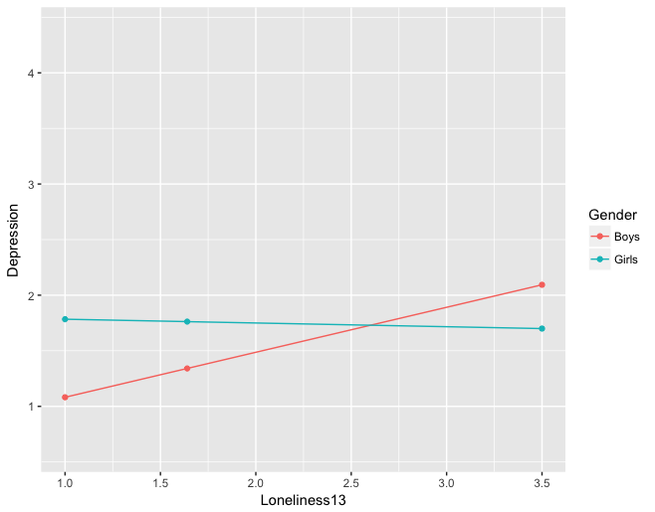

Figure 2. Simple slopes effect of loneliness at 13 years on depression at 17, evaluated at the mean of loneliness at 16 years (M = 1.49).

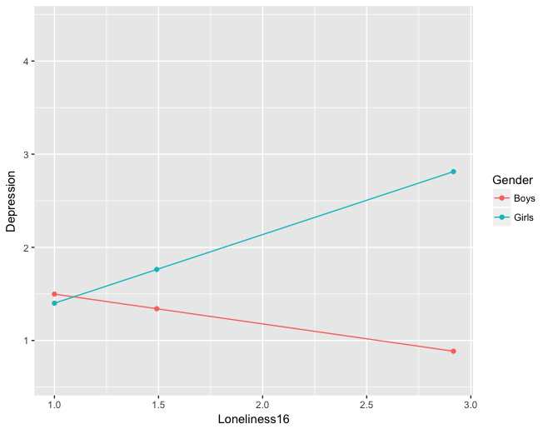

Figure 3. Simple slopes effect of loneliness at 16 years on depression at 17, evaluated at the mean of loneliness at 13 years (M = 1.64).

(3) First we tested the mediation model in which loneliness at 16 years was assumed to mediate the effect of self-esteem at 12 years on depression at 17 years. The indirect effect was negative and significant (z =-0.14, SE = 0.07, *p* = .048). The bootstrap 95% CI of the indirect effect was [-0.29; 0.01] and the standardized effect size -0.088. The direct effect in this model was positive and not statistically significant (b = 0.15, SE = 0.15, *p* = 0.310). The multiple correlation coefficient for depression was R2 = 0.109.

The second mediation model stated that self-esteem at 16 years was assumed to mediate the effect of loneliness at 13 years on depression at 17 years. The indirect effect was not significant (z =0.05, SE = 0.05, *p* = .270). The bootstrap 95% CI of the indirect effect was [-0.03; 0.16] and the standardized effect size 0.052. The direct effect in this model was positive and not statistically significant (b = 0.14, SE = 0.20, *p* = 0.480). The multiple correlation coefficient for depression was R2 = 0.135. The rather large R2 in this model is due to the strong effect of self-esteem on depression (b = -0.45, SE = 0.17, *p* = 0.008).

(Appendix Research Question 2)

R-output:

lm(formula = SCL_W10_depressie ~ CDI_W6_totaal + (LACAtotaal_W7 + LACAtotaal_W9) * Gender, data = dat)

Coefficients:

B SE t p

(Intercept) 1.1544 0.4573 2.52 0.014 *

CDI_W6_totaal -0.0187 0.3215 -0.06 0.954

LACAtotaal_W7 0.4047 0.1321 3.06 0.003 **

LACAtotaal_W9 -0.3200 0.1899 -1.69 0.096

GenderFemale -0.4362 0.4554 -0.96 0.342

LACAtotaal_W7:GenderFemale -0.4384 0.1940 -2.26 0.027 *

LACAtotaal_W9:GenderFemale 1.0571 0.2660 3.97 0.000 ***

---

Signif. codes: 0 ‘***’ 0.001 ‘**’ 0.01 ‘*’ 0.05 ‘.’ 0.1 ‘ ’ 1

Residual standard error: 0.48 on 69 degrees of freedom (53 observations deleted due to missingness)

Multiple R-squared: 0.382,

Adjusted R-squared: 0.328 ;

F-statistic: 7.1 on 6 and 69 DF, p-value: 6.41e-06